**AUC Robotics Summer Camp**

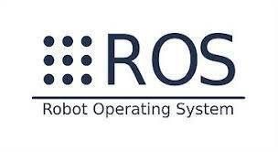

**About Instructor: Khaled Gabr**

* **Research and Development in Sensor Fusion, Mapping, Localization, Path planning and Motion planning of an Automated Guided Vehicle for warehouse management and Arm Robot.**
* **2 years working in field industrial robotics.**
* **Made a lot of projects with ROS.**

**Day 1**

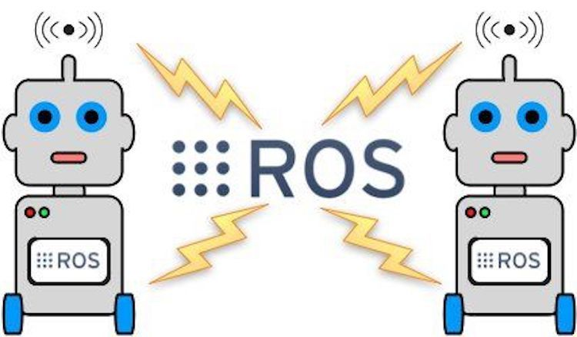

**Course Prerequisites**

* **Basics linux/ubuntu**
* **Basic in linux shell commands line**
* **Basic programming in python/C++**

**Getting Start**

* **Content of AUC Robotics Summer Camp**
* **What is ROS**
* **Why ROS**
* **History of ROS**
* **Discuss robot examples**
* **ROS version, supported OS, Robots and Sensor**

**Content of AUC Robotics Summer Camp**

* **Day 1 introduction to ROS**
* **Day 2 introduction to linux**
* **Day 3 Topics, Nodes, Services, and turtlesim move**
* **Day 4 Packages and WorkSpace**
* **Day 5 Gazebo World and RVIZ**
* **Day 6 understanding URDF**
* **Day 7 project discussion**
* **Day8**

**What is ROS**

* **ROS stands for Robot Operating System**
* **The Robot Operating System (ROS) is a framework for writing robot software.**
* **It is a collection of tools, libraries, and conventions that aim to simplify the task**

**Why ROS:**

* **Thin: ROS is designed to be as thin as possible -- we won't wrap your main() -- so that code written for ROS can be used with other robot software frameworks. A corollary to this is that ROS is easy to integrate with other robot software frameworks: ROS has already been integrated with OpenRAVE, Orocos, and Player.**
* **Language independence: the ROS framework is easy to implement in any modern programming language. We have already implemented it in** Python**, C++, and Lisp, and we have experimental libraries in Java and Lua.**
* **Easy testing: ROS has a builtin unit/integration test framework called rostest that makes it easy to bring up and tear down test fixtures.**
* **Free and Open Source**

**History of ROS**

**2007 : ROS project started under the name switchyard by the Stanford Artificial Intelligence Laboratory.**

**2008 – 2013 : ROS Development at Willow Garage, a robotics research institute.**



**2013 – Now : Open Source Robotics Foundation**

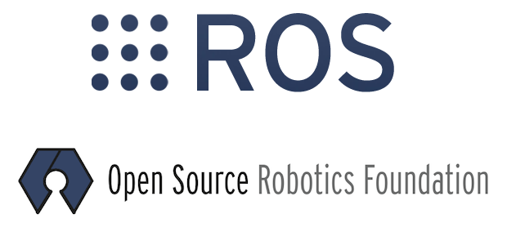

**Discuss robot examples**

**Project 1**

[**https://www.youtube.com/watch?v=S0E5wd28z2Y&t=1s**](https://www.youtube.com/watch?v=S0E5wd28z2Y&t=1s)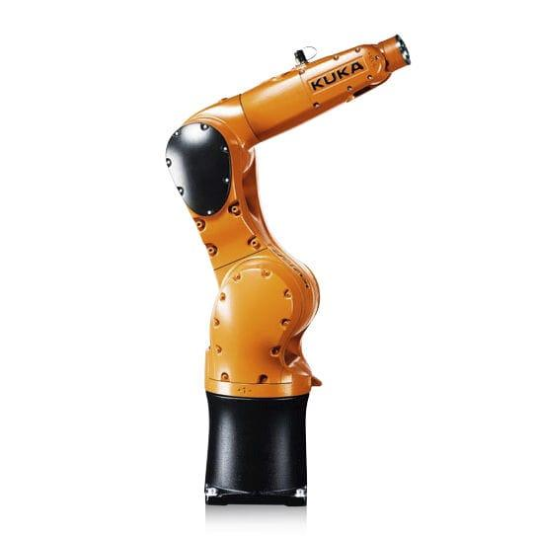

**Project 2**

[**https://www.youtube.com/watch?v=H1T2QJbw4u0**](https://www.youtube.com/watch?v=H1T2QJbw4u0)

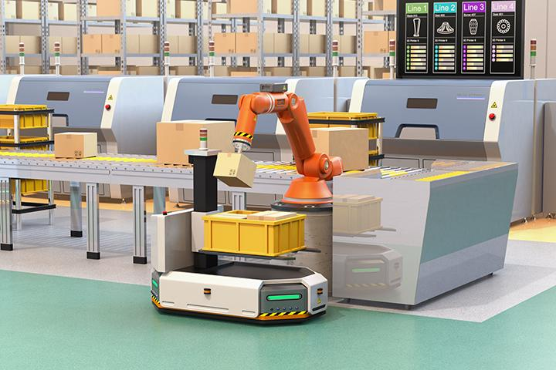

**Project 3**

[**https://www.youtube.com/watch?v=FskVOQ5izNg**](https://www.youtube.com/watch?v=FskVOQ5izNg)

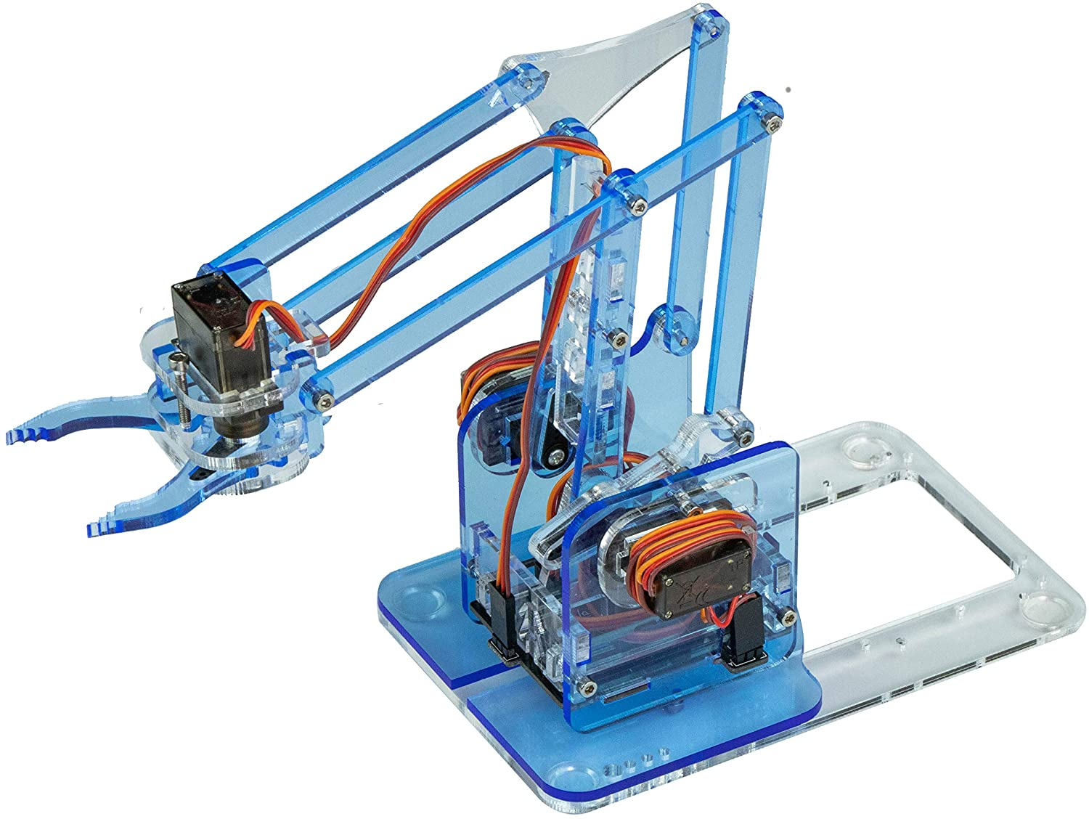

**ROS version, supported OS, Robots and Sensor**

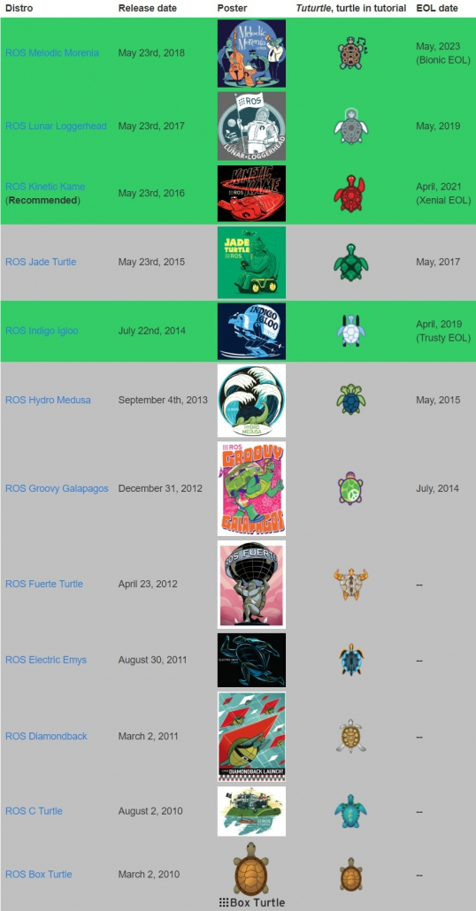

**Supporting Operating System**

**• Full Support : Ubuntu & Ubuntu(armhf)**



**Supporting Single board Computers**

**• Raspberry Pi**

**• Odroid C2, XU4**

**• NVDIA Jetson TX1, TK1**

**Robot Supporting ROS**

**•** [**http://robots.ros.org/**](http://robots.ros.org/)

**Sensors Supported in ROS**

* [**http://wiki.ros.org/Sensors**](http://wiki.ros.org/Sensors)

**Library support in ROS**

* **Moveit**
* **Gazebo**
* **OpenCv**
* **PCL**
* **ROS industrial**

**Thank you**